**APACHE HIVE**



|  |  |
| --- | --- |
| Bernice Meghan Chinthamalla | 301284811 |
| Erick Torres | 301250235 |
| Matheus Vinicius Ferreira Figueiredo Teixeira | 301236904 |
| Tessa Mathew | 301296178 |
| Arunima Jagalpriyakumari | 301274653 |
| Thejus Shaji | 301301078 |

Software Engineering Technology – Artificial Intelligence

COMP251 Sec 002 Group 3:

Table of Contents

Introduction 2

Overall Architecture and Key Technologies 5

Hive Client 5

Hive Services 5

Processing & Resource Management 5

Distributed Storage 5

Key Components of Apache Hive 5

HiveServer2 5

Key Responsibilities 5

Use Case 5

Hive Query Language (HQL) 5

Key Characteristics 5

Use Case 5

Sample HQL Commands 5

Hive Metastore 5

Key Functions 5

Use Case 5

Hive Beeline Shell 5

Key Features 5

Use Case 5

Sample Beeline Commands 5

Cloud/On-premise (Hybrid) Capabilities 5

Cloud Capabilities 5

Key Advantages 5

Example Use Case 5

On-Premise Capabilities 5

Key Advantages 5

Example Use Case 5

Hybrid Capabilities 5

Key Advantages 5

Example Use Case 5

Key Considerations for Hybrid Deployments 5

Comparison of Deployment Models 5

ELT/ETL and Data Transformation Capabilities 5

Hive's ETL Process and Key Features 5

Data Extraction 5

Data Transformation 5

Data Loading 5

Example of ETL Flow 5

ELT Workflows in Hive 5

Example of ELT Flow 5

Data Transformation Capabilities 5

Standard Functions 5

User-Defined Functions (UDFs) 5

Window Functions 5

Complex Data Types 5

Example of Using Complex Data Transformations 5

Limitations of Hive ELT/ETL and Data Transformation Capabilities 5

Security Options 5

Authentication 5

Metastore Authentication 5

HiveServer2 Authentication 5

Authorization 5

Legacy Mode 5

Storage-Based Mode 5

SQL Standard-Based Mode 5

Data Masking and Encryption 5

Data Hashing Functions 5

Data Masking Functions 5

Data Encryption Functions 5

Other Methods 5

Key competitors in the space of the Apache Hive 5

Google BigQuery 5

Overview 5

Comparison with Apache Hive 5

Conclusion 5

Amazon Redshift 5

Overview 5

Comparison with Apache Hive 5

Conclusion 5

Snowflake Data Warehouse 5

Overview 5

Comparison with Apache Hive 5

Conclusion 5

Databricks Lakehouse Platform 5

Overview 5

Comparison with Apache Hive 5

Conclusion 5

Pricing structure 5

Open-Source Nature and Cost Efficiency 5

On-Premise Deployment Costs 5

Cloud Deployment Costs 5

Hybrid Deployment Costs 5

Personnel and Training Costs 5

Comparative Cost Analysis 5

Conclusion 5

References 5

# Introduction

Apache Hive is a data warehouse and an ETL tool which provides an SQL-like interface between the user and the Hadoop distributed file system (HDFS) which integrates Hadoop. As a data warehousing framework, Hive offers a central repository for storing information that can be analyzed to support data-driven decision-making processes. Built atop Apache Hadoop, an open-source framework for distributed storage and processing, Hive allows users to read, write, and manage petabytes of data using a SQL-like interface called HiveQL. This SQL-based approach allows data analysts and professionals with no programming background to interact with big data effectively, thereby bridging the gap between traditional database usage and big data analytics.

The increasing complexity and volume of data in today's information-driven era necessitate the use of tools that can abstract the intricacies of distributed data processing. Apache Hive fulfills this role by bridging the gap between the simplicity of traditional relational database systems and the scalability required for modern big data environments. Hive enables the translation of SQL-like queries into execution plans suitable for Hadoop's underlying execution engines, such as MapReduce, Apache Tez, or Apache Spark, thus ensuring compatibility with various data processing needs.

Apache Hive is designed to integrate seamlessly with Hadoop, leveraging the Hadoop Distributed File System (HDFS) for data storage and using execution engines such as Apache Tez or MapReduce to process large datasets efficiently. One of the core strengths of Hive lies in its ability to scale to handle vast amounts of data through batch processing, transforming SQL-like queries into distributed computing jobs managed by Hadoop’s job scheduling framework, YARN (Yet Another Resource Negotiator). Unlike traditional relational databases, which are optimized for smaller datasets and interactive queries, Hive’s architecture is tailored for high-volume data processing, making it an indispensable tool for enterprises dealing with large-scale analytics.

The primary advantages of Apache Hive include its speed, familiarity, and scalability:

* **Fast**: Hive is built for processing massive datasets quickly using batch processing, which allows it to efficiently query petabytes of data.
* **Familiar**: By providing a SQL-like interface, Hive makes it accessible to users familiar with SQL, thus lowering the learning curve for working with large datasets.
* **Scalable**: Hive’s architecture is easily scalable, allowing organizations to expand their data processing capabilities as their data needs grow.

This research provides an examination of Apache Hive, its architecture, capabilities, and its role in the broader data warehousing and big data landscape. Specifically, the report will cover:

* The overall architecture of Apache Hive, including its core components and the underlying technologies that drive its functionality.
* A detailed analysis of the key components of Hive, such as the Metastore, Execution Engine, and HiveQL, and their roles within the system.
* Deployment models for Apache Hive, including its deployment in cloud environments, on-premise setups, and hybrid configurations, highlighting the flexibility of Hive in diverse operational contexts.
* The ETL (Extract, Transform, Load) and ELT (Extract, Load, Transform) capabilities that enable data transformation and integration, essential for creating meaningful insights from unstructured or semi-structured data.
* A comprehensive evaluation of the security features embedded within Hive, focusing on authentication, authorization, and encryption mechanisms to ensure robust data governance.
* A comparative overview of Apache Hive and its principal competitors in the data warehousing space, such as Google BigQuery, Amazon Redshift, and Snowflake, outlining key differentiators in terms of functionality, scalability, and use cases.
* An exploration of the pricing structure for deploying Apache Hive, addressing both the cost-efficiency of the open-source model and the deployment-related expenditures, whether on cloud platforms or on-premise infrastructures.

# Overall Architecture and Key Technologies

Hive Architecture consists in four main blocks, each one with their own components and their key technologies such as HDFS, HQL, HiveServer2, Beeline Shell or the Hive Metastore, that allow users to do efficient data queying and analysis, the main blocks are shown in the diagram below:

1. Hive Client.
2. Hive Services.
3. Processing & Resource Management.
4. Distributed Storage.

Figure   
*Architecture Diagram of Apache Hive*

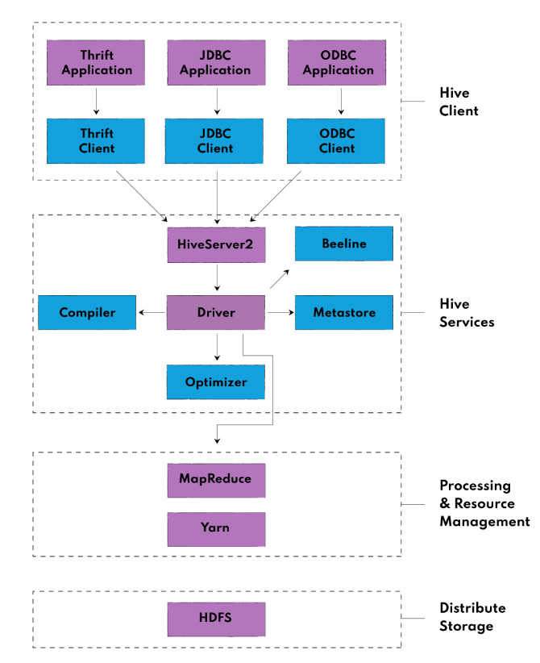

## Hive Client

Hive communicates with other clients through Thrift Server allowing external users to engage using the user interface (UI) and command-line interface (CLI) to submit queries, handle instructions, and monitor data. It supports applications written in any language like Python, Java, C++, Ruby, etc. using JDBC, ODBC, and Thrift drivers, for performing queries on the Hive.

* Thrift Clients are used due to The Hive is based on Apache Thrift.
* JDBC client can be used to connect Java applications with Hive Server.
* ODBC client allows applications based on the ODBC protocol to connect to Hive Server.

## Hive Services

The main component of the services block is the Driver, which receives the HiveQL statements requested by the user through the shell, and sending it to the compiler; this compiler, performs semantic analysis and generates an execution plan using the metadata stored in the metastore, which is finally sent to the optimizer, which performs the transformation operations on the execution plan and splits the task to improve efficiency and scalability.

The metastore is a central repository that stores the metadata information about the structure of tables and partitions with column type information. Finally, to perform all the queries, Hive provides different services such as:

* Beeline is a command shell supported by HiveServer2, where the user can submit its queries and command to the system
* Hive Server 2 enables clients to execute queries against the Hive. It allows multiple clients to submit requests and fetch the results.
* HCatalog is the table and storage management layer for Hadoop. It enables users with different data to easily read and write data on the grid.

## Processing & Resource Management

The queries are internally executed by Hive using a MapReduce architecture as the defacto engine. A software framework called MapReduce is used to develop programs that process enormous amounts of data in parallel on massive clusters of commodity hardware. Data is divided into chunks using map-reduce jobs, which then process the individual chunks.

## Distributed Storage

As Hive is built on top of Hadoop, it uses the underlying Hadoop Distributed File System for the distributed storage.

# Key Components of Apache Hive

The key components of Apache Hive—HiveServer2, Hive Query Language (HQL), Hive Metastore, and Hive Beeline Shell—work together to provide a robust and efficient framework for querying and analyzing large datasets stored in Hadoop. Each component plays a crucial role in facilitating data management, query execution, and metadata handling, making Hive a powerful data warehousing solution for big data environments.

## HiveServer2

HiveServer2 is a service that provides clients with an interface to submit Hive queries and retrieve results. It is an improved version of the original HiveServer, designed to handle multiple client connections, manage sessions, and ensure query isolation. HiveServer2 acts as the central gateway for query execution, providing a secure and efficient way to interact with Hive’s data warehousing environment. Following is a list of some of its key features.

* Supports Multi-Client Concurrency: Manages concurrent client connections using a thread-based approach, providing session isolation.
* Secure Communication: Uses Thrift-based secure communication between clients and HiveServer2.
* Resource Management: Integrates with YARN for resource allocation, ensuring efficient query execution.

### Key Responsibilities

**Session Management.** Supports multiple concurrent sessions and manages them independently, ensuring data isolation and query concurrency.

**Connection Handling.** Accepts connections from various clients such as Beeline, JDBC, and ODBC clients. It acts as an intermediary between the clients and the backend components, such as the Compiler and Execution Engine.

**Authentication and Authorization.** Integrates with security protocols like Kerberos, LDAP, and SQL-based authentication, ensuring secure access to the Hive environment.

**Query Execution Management.** Converts HQL queries into execution plans and submits them to the Execution Engine. Handles the lifecycle of queries, from parsing to returning the results to the client.

### Use Case

A financial services company uses HiveServer2 to enable analysts and data scientists to connect to the data warehouse simultaneously. HiveServer2 manages multiple sessions, allowing users to submit queries and retrieve results without any data interference or session conflicts. The ability to handle large numbers of concurrent connections ensures efficient utilization of cluster resources and timely query execution.

Figure

*Advantages and Limitations of HiveServer2*

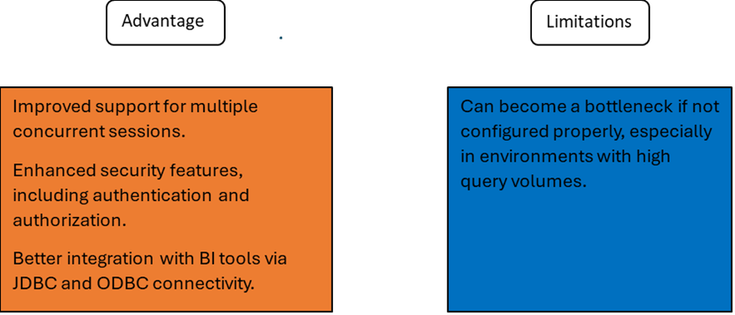

## Hive Query Language (HQL)

Hive Query Language (HQL) is a SQL-like language designed specifically for querying and managing data in Apache Hive. HQL abstracts the complexities of MapReduce programming and provides a familiar interface for users to interact with data stored in Hadoop. With HQL, users can perform a wide range of operations such as data extraction, transformation, and analysis. Some of its key features are as following listed.

* Query Optimization: HQL integrates with the Optimizer to apply techniques like predicate pushdown and partition pruning, reducing the amount of data processed and improving query performance.
* Schema Flexibility: HQL can query both structured and semi-structured data, providing flexibility in querying diverse datasets.

### Key Characteristics

**SQL Compatibility.** Provides a familiar interface for users with SQL knowledge, making it easy to write queries, define tables, and manipulate data.

**Data Definition and Manipulation.** Supports operations such as creating tables, inserting data, and altering schemas.

**Complex Data Handling.** Allows for querying complex data types like arrays, maps, and structs, providing flexibility in data modeling and querying.

**User-Defined Functions (UDFs).** Enables users to create custom UDFs to perform operations that go beyond the built-in capabilities of HQL.

### Use Case

A retail company uses HQL to analyze historical sales data stored in Hadoop. By joining sales data with customer demographics, analysts can identify buying patterns and create targeted marketing campaigns. HQL’s SQL-like syntax makes it easy to perform these complex data manipulations without needing to write Java-based MapReduce code.

Figure   
*Advantages and Limitations of Hive Query Language (HQL)*

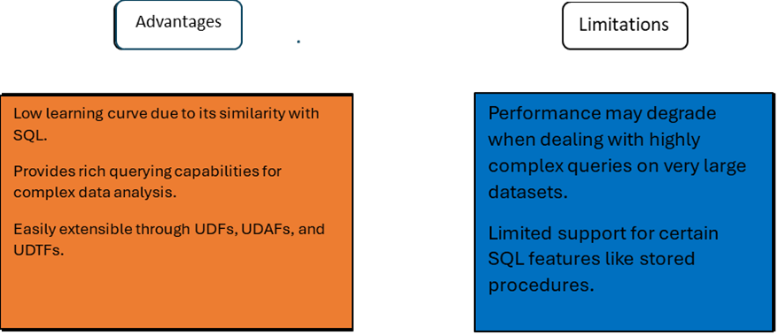

### Sample HQL Commands

-- Creating a Table in Hive

CREATE TABLE sales_data (

     sale_id STRING,

     product_id STRING,

     quantity INT,

     sale_date DATE

 ) STORED AS PARQUET;

The above command creates a table named sales_data in Hive, with the schema and storage format specified.

-- Querying Data

SELECT product_id, SUM(quantity) AS total_sales

 FROM sales_data

 WHERE sale_date BETWEEN '2023-01-01' AND '2023-12-31'

 GROUP BY product_id;

The above query retrieves the total sales for each product in the year 2023.

## Hive Metastore

The Hive Metastore is the central repository that stores metadata information such as table definitions, schemas, and partitioning details. This metadata enables Hive to manage and optimize query execution by providing necessary schema information and data location to the Hive Compiler and Optimizer.

* Thrift API: Provides an API for interacting with the Metastore, enabling tools like Apache Spark and Apache Impala to share metadata.
* Relational Database: Uses a relational database such as MySQL or PostgreSQL to store metadata, ensuring fast access and easy management.

### Key Functions

**Metadata Management.** Stores information about table structure, column data types, partition schemes, and storage locations.

**Schema Evolution Support.** Allows schema modifications without affecting existing data, making it easier to adapt to changing data structures.

**Partition Management.** Manages partition details, enabling efficient partition pruning during query execution to minimize data scanned.

### Use Case

An e-commerce company uses the Metastore to manage metadata for tables containing product details, customer information, and order histories. The Metastore stores the schema and partitioning information, allowing analysts to efficiently query and analyze historical orders based on time and product categories.

Figure

*Advantages and Limitations of Hive Metastore*

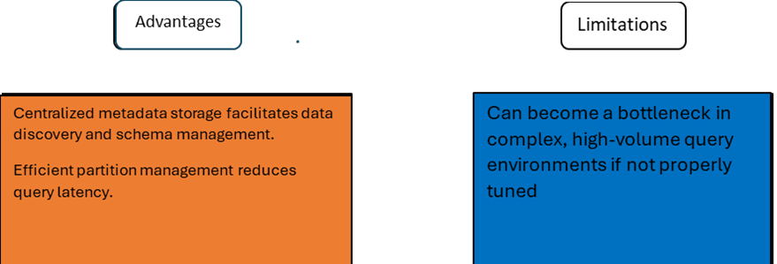

## Hive Beeline Shell

Hive Beeline is a command-line shell used to interact with HiveServer2. It provides a lightweight JDBC client for running Hive queries, performing administrative tasks, and executing batch jobs. Beeline is the preferred CLI for Hive due to its enhanced functionality, replacing the older Hive CLI.

* Integration with HiveServer2: Connects to HiveServer2 using JDBC, making it suitable for use with other JDBC-based tools and applications.
* Output Formatting: Supports multiple output formats like table, CSV, and XML, making it easy to export query results.

### Key Features

**JDBC Client for HiveServer2.** Beeline uses JDBC to connect to HiveServer2, supporting secure and robust communication.

**Batch Processing.** Allows for the execution of multiple queries from a script file, making it ideal for automated data processing tasks.

**Interactive Querying.** Supports interactive querying and result viewing, allowing users to run ad-hoc queries and perform exploratory data analysis.

### Use Case

A data engineer uses Hive Beeline to automate data validation and cleanup tasks. The engineer writes a script containing a series of HQL commands, which is executed in batch mode. The results are logged for review, ensuring that data quality is maintained before further analysis.

Figure   
*Advantages and Limitations of Hive Beeline Shell*

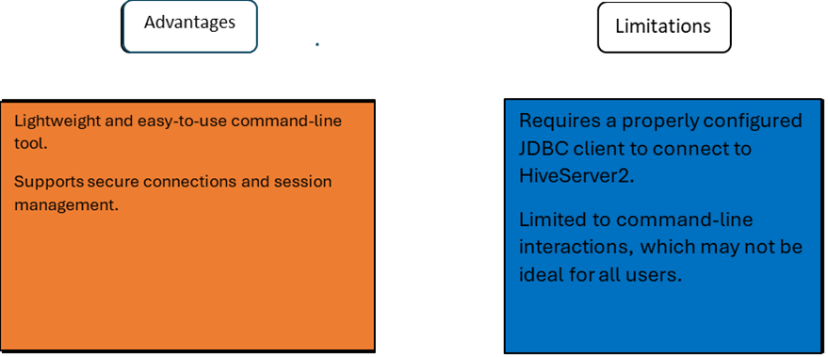

### Sample Beeline Commands

**Connecting to HiveServer2.** The following command connects Beeline to a HiveServer2 instance running on localhost on port 10000 using the default database.

!connect jdbc:hive2://localhost:10000 default

**Running a Script in Batch Mode.** The following command executes a series of HQL commands stored in query_script.sql in batch mode.

beeline -u jdbc:hive2://localhost:10000 -f /path/to/query_script.sql

# Cloud/On-premise (Hybrid) Capabilities

Apache Hive represents a data warehousing solution that is constructed upon the Hadoop ecosystem and provides versatility in its deployment options spanning, on premise setups well as cloud and hybrid environments. The hybrid deployment approach allows businesses to enjoy the advantages of cloud scalability while also retaining oversight over on premise infrastructure elements. Let's delve into an overview of Hives capabilities in both cloud and on premise settings with an emphasis on hybrid configurations.

## Cloud Capabilities

Apache Hive can easily become a part of cloud setups hosted by providers, like Amazon Web Services (AWS) Microsoft Azure or Google Cloud Platforms (GCP). In setups, in the space Hive takes advantage of the adaptability, scale and cost effectiveness that these platforms provide.

### Key Advantages

* Scalability: It is essential for organizations with varying data processing needs as cloud platforms offer flexible resource allocation that enables Hive to adapt to workload demands.
* Managed Services: Cloud service companies frequently provide managed Hadoop services, like AWS EMR and Azure HDInsight to streamline the setup and maintenance of Hive environments, for users convenience and lessen the burden of overseeing hardware infrastructure tasks.
* Pay-As-You-Go: Cloud services work based upon a pay, as you go system where organizations can steer clear of expenses tied to buying hardware by only paying for the storage and computing resources they actually use.

### Example Use Case

One way a retail business might leverage Apache Hive on a cloud service, like AWS is for storing and examining sets of data like sales figures and customer interactions analysis data points. During selling periods when there's a surge in sales statistics to process efficiently without needing hardware constantly available during quieter periods.

## On-Premise Capabilities

On-premise deployment of Apache Hive means installation of the software in a specific infrastructure in the organization. This model gives the total control of the data and the hardware which is critical in organizations required to conform to specific rules and those dealing with sensitive information.

### Key Advantages

* Data Security: On-premise offers organizations complete ownership of centralized data, which means that information considered confidential is contained in the organization’s network. This is particularly crucial for businesses that work in domains requiring compliance with stringent data usage regulatory frameworks – like finance or health, GDPR, and HIPAA, to name some.
* Customization and Control: One of the key advantages of on-premise deployment of Hadoop and Hive is the level of flexibility which companies can have while making the setup. They are in a position to design infrastructure with the right features for the job that is at hand.
* Legacy System Integration: Due to its compatibility with the data storage architecture of Hadoop, the use of Hive does not depend on outside cloud facilities for those organizations that already possess on-premise systems. This helps you to integrate with other on-premises applications in a perfect way.

### Example Use Case

An example where an organization would choose an on-premise Hive could be where the financial institution collecting sensitive customer data wanted to keep control of said data. Hive can be used by the organization to store data locally to meet stringent requirements of financial industry regulations while being able to take full advantage of the incredible query and analytical capabilities of Hive.

## Hybrid Capabilities

The hybrid deployment model consists of both on-premise and cloud abilities, and helps organizations acquire the strengths of every form while avoiding the flaws of either. In such a model, companies can store restricted information locally and at the same time leverage the benefits of cloud for big data processing and storage.

### Key Advantages

* **Data Flexibility:** Hybrid environments allow for central computing to occur through a mixture of both on premise solutions and cloud solutions. Restrictive or high-risk data stays centralized and locked down on the company’s local premises, while less risky data is migrated to the cloud for processing.
* **Cost Flexibility:** The blending of the traditional centralized computing environments with these service computers is beneficial in preventing organizations from procuring excess hard structures. It allows enterprises to perform some of their intense processing in-house but use cloud services when they need it or during big-data analysis.
* **Disaster Recovery and Backup:** With hybrid models, for example, organizations get the advantage of storing the backup data in the cloud so that in case of a disaster, the data can be recovered. In case of any failure in an on-premise system, the workload can easily be transferred to the cloud to allow business to continue.

### Example Use Case

Depending on the business specifics an e-commerce company may use Hive both on-site to store current customer transactions, sensitive user data and in combination with off-site solutions for various purposes. However, the sales data of a particular product along with the records of user usage patterns could be archived with cloud resources analyzing the trends to support long-term marketing.

### Key Considerations for Hybrid Deployments

When deploying Apache Hive in a hybrid environment, organizations should consider the following.

**Data Movement.** In this case, efficient ways through which data will be moved between on-premise and cloud are essential to enable efficient processing. Data migration and synchronization types of tools such as Apache NiFi, or Apache Sqoop can be used.

**Integration.**This requires that the hybrid environment is well integrated so that there can be easy running of workloads on-premise and on the cloud. This could be done using federated queries or storage options such as Amazon S3 together with local Hadoop clusters.

**Cost Management.** While hybrid models can minimize cost, communication between on-premise and cloud systems and cloud storage may attract extra cost. These costs should be controlled by organizations in the best way possible.

## Comparison of Deployment Models

Table   
*Comparison of Deployment Models*

| **Characteristic** | **On-Premise** | **Cloud** | **Hybrid** |
| --- | --- | --- | --- |
| Infrastructure Control | Full control over hardware and data | Managed by cloud provider | Control over critical data; cloud for scalability |
| Scalability | Limited by physical resources | Infinite scalability based on demand | Scalable cloud resources with on-premise control |
| Cost Model | High upfront and maintenance costs | Pay-as-you-go, low initial costs | Optimized costs by leveraging both models |
| Data Security | High security, all data stays on-prem | Secure, but some concerns about third-party access | Sensitive data stays on-premise, cloud for non-critical tasks |
| Maintenance | Handled by internal IT teams | Maintenance is managed by clod provider | Mixed, with cloud managed externally and on-premise managed internally |
| Compliance | Ideal for industries with strict regulations | Cloud providers offer security certifications, but compliance concerns remain | Meets both regulatory and scalability needs |
| Disaster Recovery | Requires on-prem backups | Cloud providers offer disaster recovery services | Cloud used for backup and failover |

# ELT/ETL and Data Transformation Capabilities

Apache Hive, an essential part of the Hadoop ecosystem, excels in managing Extract, Transform, Load (ETL) and Extract, Load, Transform (ELT) processes for various data types, including structured, semi-structured, and unstructured data. Unlike traditional ETL tools designed primarily for structured data, Hive is built to operate within the Hadoop Distributed File System (HDFS), treating data with a schema-based, SQL-like structure, which facilitates querying and transformation tasks. Hive's ETL process leverages the power of MapReduce, enabling it to handle complex batch processing tasks by loading data into HDFS or Hive tables before transformation (IBM Developer, n.d.).

One of the key advantages of Hive lies in its support for ELT workflows. In these workflows, data is first extracted and loaded into HDFS, allowing transformations to occur post-loading. This approach offers significant scalability benefits, particularly when handling large datasets. Although Hive's reliance on MapReduce may introduce performance bottlenecks in non-batch-oriented tasks, its integration with open-source tools helps mitigate these limitations, providing a robust framework for real-world data transformation needs (IBM Developer, n.d.).

## Hive's ETL Process and Key Features

Apache Hive delivers powerful ETL capabilities that allow users to extract data from a variety of sources, transform it to meet specific business or technical requirements, and load it into the target storage system, such as tables or files within HDFS. One of Hive's strengths lies in its ability to handle large datasets with a familiar SQL-like syntax, enabling both data engineers and analysts to work efficiently without needing in-depth knowledge of MapReduce. Additionally, Hive’s integration with the Hadoop ecosystem ensures seamless scalability and flexibility, allowing it to handle both batch-oriented and interactive data queries (Microsoft, n.d.).

Key features of Hive’s ETL process include schema flexibility, as Hive can process structured, semi-structured, and unstructured data through its extensible framework. Furthermore, Hive supports a wide variety of input formats, which enables users to extract data from disparate sources while transforming it into a standardized schema for easy querying and analysis. Its compatibility with other tools in the Hadoop ecosystem, like Apache Pig, further strengthens Hive’s ETL capabilities by allowing users to apply complex data transformations (Microsoft, n.d.).

### Data Extraction

Hive can extract data from multiple sources, including:

* Relational databases (via JDBC)
* Flat files (CSV, JSON, XML)
* Hadoop Distributed File System (HDFS)
* NoSQL databases (HBase, Cassandra)

### Data Transformation

Hive offers a wide range of transformation capabilities:

* Data type conversions
* Column renaming and reordering
* Filtering and aggregation
* Join operations
* Window functions

### Data Loading

Transformed data can be loaded into:

* Hive tables
* External storage systems
* HDFS files

### Example of ETL Flow

Hive's ETL process typically involves writing HiveQL queries to perform these operations. For example, to extract data from a CSV file, transform it, and load it into a Hive table:

-- Create a table to store the transformed data

CREATE TABLE transformed_data (

  id INT,

  name STRING,

  age INT,

  salary DOUBLE

);

-- Extract data from CSV, perform transformations, and load into the table

INSERT OVERWRITE TABLE transformed_data

SELECT

  id,

  UPPER(name) as name,

  age,

  salary * 1.1 as adjusted_salary

FROM external_table

WHERE age > 18;

The above query extracts data from an external table (which could be mapped to a CSV file), performs transformations (uppercase names, filter by age, adjust salary), and loads the result into the transformed_data table.

## ELT Workflows in Hive

In addition to traditional ETL workflows, Hive effectively supports ELT (Extract, Load, Transform) workflows, offering a number of advantages in large-scale data processing environments. One key benefit is the flexibility to load raw data first and apply transformations later. This approach is especially useful when dealing with evolving data requirements, as transformations can be adapted without needing to re-extract the data from the source.

Hive's ELT workflows take full advantage of its ability to handle both structured and unstructured data, which aligns with its schema-on-read capability. This allows users to define the structure of the data at query time, making it easier to work with diverse data formats. Furthermore, Hive’s integration with Hadoop's distributed architecture ensures scalability, enabling the efficient handling of large datasets (IBM Developer, n.d.).

### Example of ELT Flow

-- Extract and load data into a staging table:

CREATE EXTERNAL TABLE raw_data (col1 STRING, col2 STRING, ...)

ROW FORMAT DELIMITED

FIELDS TERMINATED BY ','

LOCATION '/path/to/raw/data';

-- Transform data as needed:

CREATE TABLE transformed_data AS

SELECT

  CAST(col1 AS INT) as id,

  UPPER(col2) as name,

  -- other transformations

FROM raw_data;

## Data Transformation Capabilities

Hive offers extensive data transformation capabilities, as presented in the next subsections

### Standard Functions

According to Capriolo, Wampler, and Rutherglen (2012), Hive provides a wide array of Standard Functions:

* + mathematical functions (e.g., round() and floor())
  + String manipulation (e.g., ucase(), and reverse())
  + Aggregate Functions (e.g., sum(), and avg())
  + Table Generating Functions (e.g., explode() and array())

### User-Defined Functions (UDFs)

Hive's User-Defined Functions (UDFs) are a key feature that allows users to extend HiveQL by creating custom functions for specific transformations. These functions are implemented in Java and, once registered, behave like built-in functions. UDFs enable users to perform complex transformations within their queries, eliminating the need to move data between systems or write custom MapReduce jobs. This approach increases efficiency, especially when dealing with large datasets, and simplifies the ETL process by running directly within the Hive query engine. Best practices for creating and using UDFs are essential to maximizing their effectiveness in large-scale data processing (Capriolo, Wampler, & Rutherglen, 2012).

### Window Functions

Window functions, introduced in Hive v0.11.0, provide a way to perform calculations across a set of table rows that are related to the current row. Unlike standard aggregate functions that return a single result for each group of rows (using GROUP BY), window functions return multiple results while preserving individual row data. They operate within partitions defined by the PARTITION BY clause and can be ordered using the ORDER BY clause, making them highly flexible. Functions such as sum(), rank(), lead(), and lag() can be applied within these windows to deliver advanced analytics and sorting. This method allows for more complex queries compared to traditional aggregation, without collapsing the data into fewer rows (Du, 2018).

### Complex Data Types

Hive's support for collection data types such as structs, maps, and arrays, which are not commonly found in traditional relational databases. These data types allow for the embedding of complex data structures within records, enabling higher processing throughput and minimizing disk seeks in Big Data systems. While this approach may sacrifice normal form and risk data duplication, it offers significant performance benefits by facilitating faster data retrieval (Capriolo et al., 2012).

Arrays, maps, and structs are beneficial for sophisticated data modeling and transformation because they allow for the representation of nested and hierarchical data structures within a single table. This flexibility simplifies data processing tasks and enables more complex analytical operations, making it easier to manage and analyze large and intricate datasets efficiently.

### Example of Using Complex Data Transformations

SELECT

  id,

  name,

  CASE

    WHEN age < 30 THEN 'Young'

    WHEN age BETWEEN 30 AND 50 THEN 'Middle-aged'

    ELSE 'Senior'

  END AS age_group,

  RANK() OVER (PARTITION BY department ORDER BY salary DESC) as salary_rank

FROM employees;

The above query demonstrates the use of conditional logic, window functions, and data categorization in a single transformation.

## Limitations of Hive ELT/ETL and Data Transformation Capabilities

While Hive's transformation capabilities are powerful, it's important to note some limitations:

* Performance can be slower compared to specialized ETL tools for certain operations (IBM Developer, n.d.).
* Complex transformations may require multiple steps or custom UDFs, increasing development time.
* Real-time or streaming transformations are not natively supported, requiring integration with other tools like Apache Spark or Flink for such use cases.

In conclusion, Apache Hive provides robust ETL/ELT and data transformation capabilities, making it a versatile tool for handling large-scale data processing tasks. Its SQL-like interface, combined with the power of Hadoop's distributed processing, enables data professionals to efficiently manage and analyze big data, supporting a wide range of use cases from data warehousing to advanced analytics.

# Security Options

Ensuring data security is crucial for any software in production, and Apache Hive is no exception. As a leading SQL-like interface for Hadoop, Hive integrates security features to protect and control access to data (Du, 2018). This section discusses Hive's security options in terms of authentication, authorization, and data masking and encryption.

## Authentication

Authentication verifies the identity of users accessing Hive. Since the introduction of HiveServer2, Hive has supported various authentication methods, enhancing security beyond reliance on Hadoop Distributed File System (HDFS) (Du, 2018).

### Metastore Authentication

The Hive metastore can enforce client authentication using Kerberos, a network authentication protocol developed by MIT. By configuring specific properties in the hive-site.xml file, clients are required to authenticate with Kerberos before accessing the metastore. This involves enabling the Simple Authentication and Security Layer (SASL), specifying the Kerberos keytab file, and setting the Kerberos principal (Du, 2018).

### HiveServer2 Authentication

HiveServer2 supports multiple authentication modes, including Kerberos, LDAP, PAM, and custom implementations. Configuration involves setting the hive.server2.authentication property to the desired mode in the hive-site.xml file (Du, 2018).

**Kerberos.** Secure authentication between clients and HiveServer2, as well as HiveServer2 and HDFS (Du, 2018).

**LDAP.** Validates user credentials against an LDAP directory (Du, 2018).

**Custom Authentication.** Allows the implementation of a custom authentication class by specifying it in the configuration (Du, 2018).

**PAM.** Since Hive version 0.13.0, Pluggable Authentication Modules (PAM) can be used for authentication, enabling the integration of existing authentication mechanisms (Du, 2018).

## Authorization

Authorization determines whether a user has permission to perform specific actions on data or metadata. Hive provides three authorization modes: legacy mode, storage-based mode, and SQL standard-based mode (Du, 2018).

### Legacy Mode

Legacy mode is the default authorization in Hive, offering column- and row-level controls through Hive Query Language (HQL) statements. However, it is not fully secure and mainly prevents accidental misuse rather than malicious activities (Du, 2018).

### Storage-Based Mode

Introduced in Hive version 0.10.0, storage-based authorization relies on HDFS permissions, including POSIX and Access Control Lists (ACLs), to control access. It provides authorization at the database, table, and partition levels but lacks flexibility for column- and row-level controls (Du, 2018).

### SQL Standard-Based Mode

For fine-grained access control, SQL standard-based authorization, available since Hive version 0.13.0, uses GRANT and REVOKE statements similar to traditional relational databases. This mode allows column- and row-level permissions but only authorizes users accessing data through HiveServer2, not through other tools like Hive CLI or HDFS command. It is often recommended to use both storage-based and SQL standard-based modes together for comprehensive security (Du, 2018).

## Data Masking and Encryption

Protecting sensitive data such as Personally Identifiable Information (PII) is essential. Hive provides data hashing, masking, and encryption functions to secure data at rest and in transit (Du, 2018).

### Data Hashing Functions

Data hashing functions like md5, sha1, and sha2 generate fixed-size alphanumeric strings from input data, which can be used to secure unique identifiers without revealing the original values (Du, 2018).

### Data Masking Functions

Since Hive version 2.1.0, built-in data masking functions allow partial masking of sensitive information, offering flexibility to retain parts of the data for readability while protecting confidential segments (Du, 2018).

### Data Encryption Functions

Hive supports data encryption and decryption using the Advanced Encryption Standard (AES) algorithm through functions like aes_encrypt and aes_decrypt. This enables the secure storage and retrieval of sensitive data (Du, 2018).

### Other Methods

Additional security measures include integrating Apache Sentry or Apache Ranger for advanced authorization controls and leveraging HDFS encryption for transparent encryption and decryption of entire datasets (Du, 2018).

# Key competitors in the space of the Apache Hive

Built on the Hadoop ecosystem, Apache Hive offers reliable warehousing solutions for batch processing. However, as technology advances, several modern platforms have emerged offering enhanced performance, scalability, and ease of use. In this section, we state and compare four key competitors with Apache Hive: Google BigQuery, Amazon Redshift, Snowflake Data Warehouse, and Databricks Lakehouse Platform.

## Google BigQuery

### Overview

Google BigQuery is a serverless, highly scalable data warehouse that comes with a built-in query engine. It is a fully managed, AI-ready data platform that helps you to manage and analyze your data with built-in features like machine learning, search, geospatial analysis, and business intelligence. BigQuery's serverless architecture lets you use languages like SQL and Python to answer your organization's biggest questions with zero infrastructure management.

### Comparison with Apache Hive

Table   
*Comparison Google Big Query vs. Apache Hive*

|  |  |  |
| --- | --- | --- |
| **Feature** | **Apache Hive** | **Google BigQuery** |
| Architecture | Hadoop-based batch processing with MapReduce, Tez, or Spark | Serverless, columnar storage for real-time analytics |
| Ease of Use | Requires Hadoop expertise | Fully managed; no infrastructure setup |
| Performance | Best for batch processing | Fast, real-time query execution |
| Scalability | Scales manually with Hadoop clusters | Automatically scales based on workload |
| Real-Time Analytics | Limited | Supports real-time analytics |
| Query Language | HiveQL | Standard SQL |
| Cost | Free, but requires infrastructure management | Pays per query; can become expensive |

### Conclusion

Except for pricing, Google BigQuery performs better than Apache Hive, making it the superior option for scalability, ease of use, and real-time analytics. In settings where batch processing is the focus and Hadoop is already in place, Hive can still be favored, although BigQuery has several benefits for contemporary data warehousing requirements.

## Amazon Redshift

### Overview

Amazon Redshift is a fully managed, petabyte-scale data warehouse service in the cloud. Amazon Redshift Serverless lets you access and analyze data without all the configurations of a provisioned data warehouse. Resources are automatically provisioned, and data warehouse capacity is intelligently scaled to deliver fast performance for even the most demanding and unpredictable workloads.

### Comparison with Apache Hive

Table   
*Comparation Amazon Redshift vs. Apache Hive*

|  |  |  |
| --- | --- | --- |
| **Feature** | **Apache Hive** | **Amazon Redshift** |
| Architecture | Hadoop-based batch processing with MapReduce, Tez, or Spark | MPP, columnar storage, and data compression for optimized query performance |
| Ease of Use | Requires Hadoop expertise | AWS-managed, easier with built-in tools for cluster management |
| Performance | Best for batch processing | Fast query performance with MPP and data compression |
| Scalability | Scales manually with Hadoop clusters | Automatically adds nodes for seamless scaling |
| Real-Time Analytics | Limited | Primarily batch but can handle real-time ETL |
| Query Language | HiveQL | Standard SQL |
| Cost | Free, but requires infrastructure management | Based on usage; can become expensive at scale |

### Conclusion

Amazon Redshift's scalability and quick performance make it more appropriate for analytical queries and structured data. Compared to Hive, it delivers better query execution and is simpler to maintain. However, if Hadoop infrastructure is already in place, Apache Hive is more economical, making it a better option for batch processing at a reduced cost.

## Snowflake Data Warehouse

### Overview

Snowflake is a scalable, cloud-based data warehouse used for data storage, processing and data analytics. The whole data warehouse is built on top of Google Cloud, Microsoft Azure and Amazon Web Services, and can support multi-cloud environments. It supports semi-structured and structured data sets as well as store and process unstructured data.

### Comparison with Apache Hive

Table   
*Comparation Snowflake Data Warehouse vs. Apache Hive*

|  |  |  |
| --- | --- | --- |
| **Feature** | **Apache Hive** | **Snowflake**  **Data Warehouse** |
| Architecture | Hadoop-based batch processing with MapReduce, Tez, or Spark | Cloud-based; Hybrid of shared-disk and shared nothing databases; Uses MPP clusters |
| Ease of Use | Requires Hadoop expertise | User-friendly |
| Performance | Best for batch processing | Fast querying, high concurrency support |
| Scalability | Scales manually with Hadoop clusters | Elastic scaling, auto-adjusts compute and storage |
| Real-Time Analytics | Limited | Real-time analytics and high concurrency |
| Query Language | HiveQL | Standard SQL |
| Cost | Free, but requires infrastructure management | Usage-based pricing, can become expensive |

### Conclusion

Snowflake excels in scalability, performance, and user-friendliness, making it perfect for real-time analytics and high concurrency. Although less expensive, Apache Hive lacks Snowflake's real-time capabilities and needs more manual control. In general, Snowflake is a better option for contemporary, scalable data warehousing, whereas Hive is still useful for situations that are batch-focused and cost-conscious.

## Databricks Lakehouse Platform

### Overview

A Data Lakehouse is a new, open data management architecture that combines the flexibility, cost-efficiency, and scale of data lakes with the data management and ACID transactions of data warehouses, enabling business intelligence (BI) and machine learning (ML) on all data. It is suitable for both large-scale storage and high-performance querying.

### Comparison with Apache Hive

Table   
*Comparison Databricks Lakehouse Platform vs. Apache Hive*

|  |  |  |
| --- | --- | --- |
| **Feature** | **Apache Hive** | **Databricks Lakehouse Platform** |
| Architecture | Hadoop-based batch processing with MapReduce, Tez, or Spark | Unified architecture combining data lakes and data warehouses |
| Ease of Use | Requires Hadoop expertise | User-friendly; multi-language support |
| Performance | Best for batch processing | Fast batch and real-time processing |
| Scalability | Scales manually with Hadoop clusters | Scales seamlessly on cloud platforms |
| Real-Time Analytics | Limited | Excellent support for real-time data |
| Query Language | HiveQL | Supports SQL, Python, R |
| Cost | Free, but requires infrastructure management | Usage based; can be expensive for large workloads |

### Conclusion

Databricks Lakehouse excels in batch and real-time processing, making it a better fit for data science, machine learning, and advanced analytics. Its support for multiple languages and dynamic scaling across cloud platforms makes it far more versatile than Apache Hive, which is primarily suited for traditional batch processing.

# Pricing structure

Apache Hive, as an open-source data warehousing solution, provides significant cost advantages compared to proprietary tools. However, deploying and maintaining Hive incurs various costs, which depend on the chosen deployment model, infrastructure requirements, and the personnel involved. This section explores the key elements that contribute to the overall cost of deploying Apache Hive, categorized into open-source benefits, on-premise costs, cloud deployment, hybrid options, and personnel considerations.

## Open-Source Nature and Cost Efficiency

One of the primary advantages of Apache Hive is its open-source nature, meaning there are no direct licensing fees. Unlike proprietary data warehousing tools, Hive can be freely downloaded, customized, and used without incurring licensing costs, making it an attractive option for cost-conscious organizations. Additionally, Hive benefits from an active open-source community that provides ongoing support and development, which can also contribute to reduced software costs.

## On-Premise Deployment Costs

For organizations opting for on-premise deployment, the total cost of ownership (TCO) includes significant initial investments in hardware and infrastructure.

**Hardware Costs.** On-premise deployment of Hive requires physical servers, storage, and networking equipment capable of handling big data processing. The hardware requirements depend on the scale of data and the processing workload.

**Operational Costs.** Maintaining a Hadoop cluster on-premise involves costs related to power, cooling, physical space, and hardware maintenance.

**Personnel Costs.** Skilled IT personnel, including system administrators and data engineers, are necessary to manage and maintain on-premise infrastructure. This requires ongoing operational expenditure to ensure optimal performance and reliability of the system.

## Cloud Deployment Costs

Cloud deployment is an attractive option for organizations looking to avoid the high initial costs associated with on-premise infrastructure. Managed Hadoop services, such as Amazon EMR, Azure HDInsight, or Google Cloud Dataproc, integrate with Hive and provide scalable infrastructure for data processing. Costs associated with cloud deployment include:

* **Compute Costs**: The cost of running Hive in a cloud environment is determined by the type and number of virtual machines required to process data.
* **Storage Costs**: Data stored on cloud platforms such as Amazon S3, Azure Blob Storage, or Google Cloud Storage incurs recurring charges based on the volume of data and the retention duration.
* **Data Transfer Costs**: Costs are associated with data movement between cloud services, particularly when large datasets are transferred across regions or services.

## Hybrid Deployment Costs

A hybrid deployment combines on-premise and cloud environments, allowing organizations to maintain sensitive data on-premise while leveraging cloud resources for scalability.

**Integration Costs.** Costs associated with integrating on-premise and cloud environments, including software tools and personnel expertise, contribute to the TCO.

**Flexibility.** Hybrid deployments offer the advantage of scalability while retaining control over critical data.

## Personnel and Training Costs

Other key cost consideration involves the personnel required to manage and operate Apache Hive:

* **Data Engineers and System Administrators**: Qualified personnel are required to manage Hadoop clusters, whether on-premise or cloud-based, ensuring optimal performance and reliability.
* **Training Costs**: Given the complexities of Apache Hive and its integration with Hadoop, organizations may need to invest in employee training to equip them with the necessary skills to use and manage the system effectively.

## Comparative Cost Analysis

When compared to proprietary data warehousing solutions such as Snowflake, Amazon Redshift, or Google BigQuery, Apache Hive offers significant cost benefits due to its open-source nature and the flexibility of deployment options. However, the total cost of ownership must consider not only the infrastructure costs but also personnel, training, and ongoing operational costs. For organizations with existing Hadoop infrastructure, adopting Hive represents a cost-effective solution. On the other hand, managed cloud-based data warehousing tools offer better cost predictability and ease of maintenance, making them a suitable option for organizations that prioritize convenience over direct control.

# Conclusion

In conclusion, Apache Hive plays a pivotal role in the landscape of big data processing and data warehousing by providing a robust, scalable, and SQL-like interface for managing vast amounts of data. Built on top of the Hadoop ecosystem, Hive bridges the gap between traditional database systems and the modern need for distributed processing. Its architecture supports large-scale batch processing and seamless integration with Hadoop’s distributed storage, making it an indispensable tool for enterprises dealing with petabytes of data.

With a flexible deployment model that spans on-premise, cloud, and hybrid configurations, Hive offers organizations the adaptability needed to meet diverse operational demands. It also supports robust ETL and ELT processes, advanced security mechanisms, and powerful transformation capabilities, while maintaining cost-efficiency through its open-source nature.

However, in a competitive space, Hive is increasingly challenged by modern data warehousing solutions like Google BigQuery, Amazon Redshift, Snowflake, and Databricks Lakehouse, which offer improved performance, real-time analytics, and easier management. While Hive remains a viable solution for organizations with existing Hadoop infrastructure, businesses seeking real-time processing, cloud scalability, or ease of use may find these competitors more suitable for their needs.

Ultimately, Apache Hive's value lies in its ability to handle large-scale, batch-oriented analytics with cost-effective scalability, making it a key player in the realm of big data, despite growing alternatives in the market.

# References

Amazon Web Services (AWS). (n.d.). Use Apache Hive on Amazon EMR. AWS Documentation. <https://docs.aws.amazon.com/emr/latest/ReleaseGuide/emr-hive.html>

Apache Hive: Data warehouse for Hadoop | DataBricks. (n.d.). Databricks. <https://www.databricks.com/glossary/apache-hive#:~:text=The%20key%20components%20of%20the,and%20the%20Hive%20Beeline%20Shell>

Apache Hive. (n.d.). Apache Hive official website. Apache Software Foundation. <https://hive.apache.org/>

Bansal, H., Chauhan, S., & Mehrotra, S. (2016). *Apache Hive Cookbook*. Packt Publishing. <https://learning.oreilly.com/library/view/apache-hive-cookbook/9781782161080/>

Capriolo, E., Wampler, D., & Rutherglen, J. (2012). *Programming Hive*. O'Reilly Media, Inc. <https://learning.oreilly.com/library/view/programming-hive/9781449326944/>

Du, D. (2018). *Apache Hive Essentials* (2nd ed.). Packt Publishing. <https://learning.oreilly.com/library/view/apache-hive-essentials/9781788995092/c922e0ff-3606-43bf-9723-e5cd1619eb43.xhtml>

IBM Developer. (n.d.). *Hive as a tool for ETL or ELT*. IBM Developer. <https://developer.ibm.com/tutorials/bd-hivetool/>

Microsoft. (n.d.). *Using Apache Hive as an ETL tool on Azure HDInsight*. Microsoft Learn. <https://learn.microsoft.com/en-us/azure/hdinsight/hadoop/apache-hadoop-using-apache-hive-as-an-etl-tool>

Microsoft. (n.d.). *What is a data lakehouse?* Microsoft Learn. <https://learn.microsoft.com/en-us/azure/databricks/lakehouse/>

Snowflake. (n.d.). *Key concepts & architecture.* Snowflake Documentation. <https://docs.snowflake.com/en/user-guide/intro-key-concepts>

Team, D. (2017, September 2). Apache Hive Architecture - Complete Working of Hive with Hadoop - DataFlair. *DataFlair*. <https://data-flair.training/blogs/apache-hive-architecture/>

Tigani, J., & Lakshmanan, V. (2019). *Google BigQuery: The Definitive Guide.* O'Reilly Media. <https://www.oreilly.com/library/view/google-bigquery-the/9781492044451/ch01.htm>